

Application of ICT Lab
BS CYFS 2025
Lab Task 9
Name: Ibrahim Bin Arif
Roll no: 2503541

Submitted to : Miss Laraib Javaid

Introduction to Python

Task 1: Writing python program in cmd.
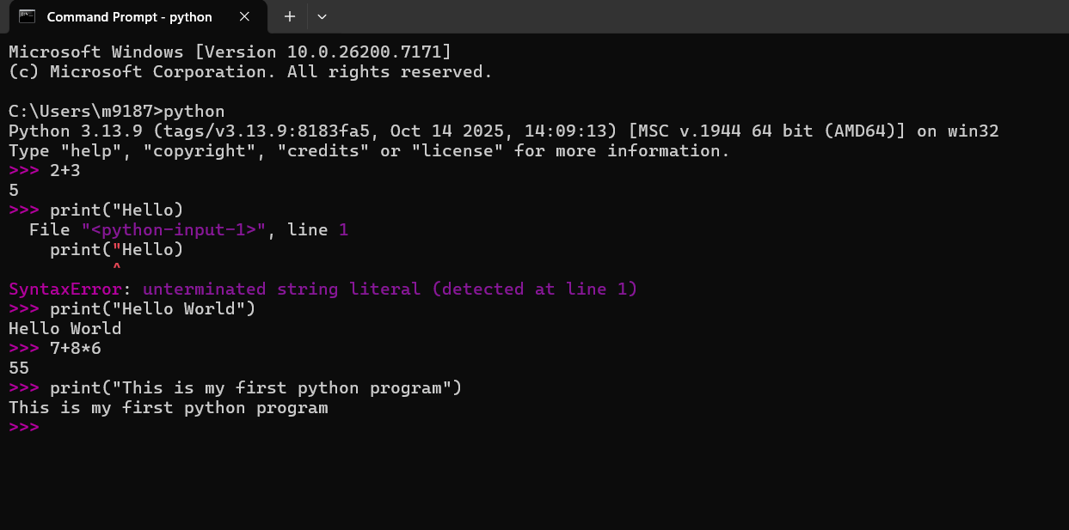
Task 2: Executing python file from cmd.
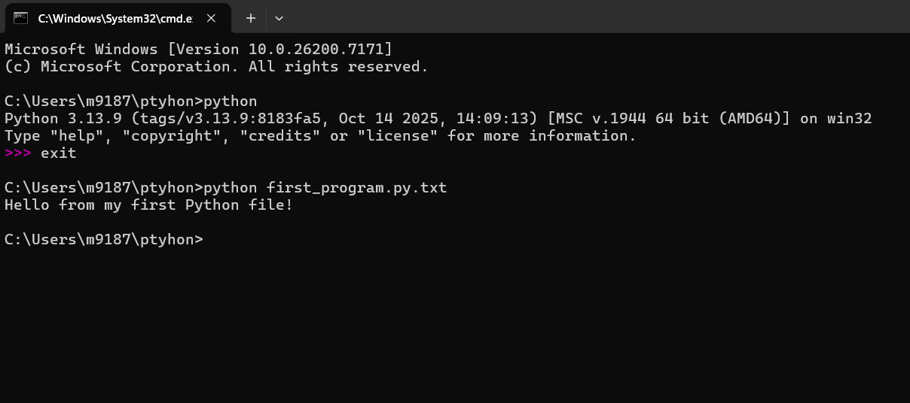
Next step: Installing VS code.
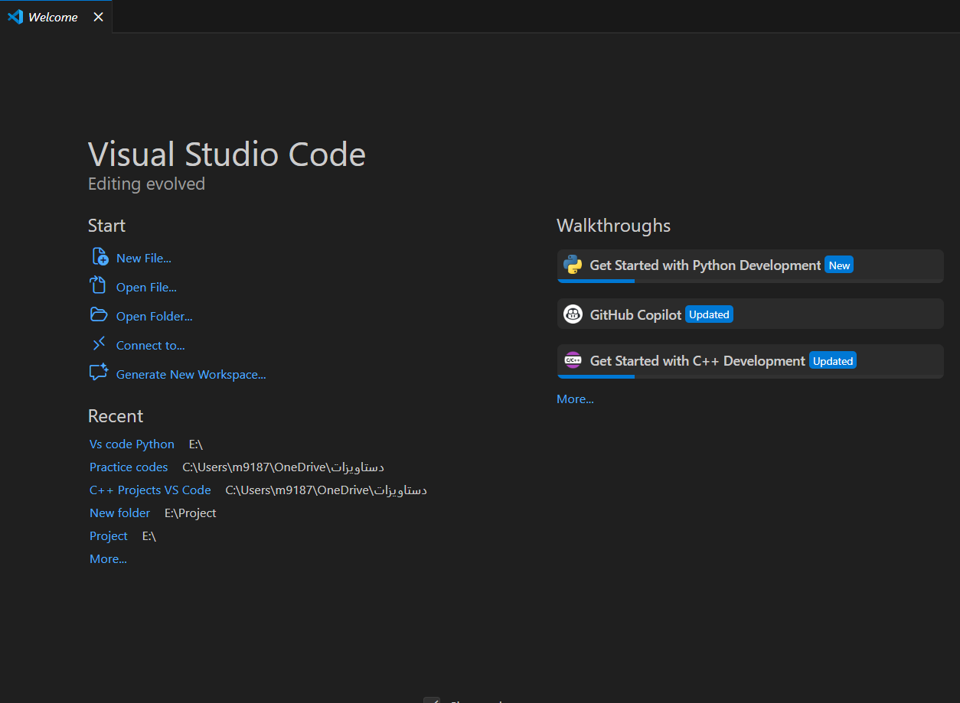
Task 3: Installing Python extension in Visual Studio code
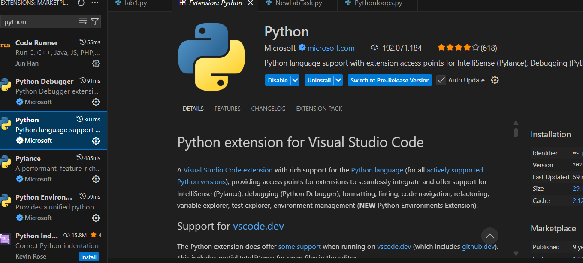
Task 4: Writing first code in VS Code.
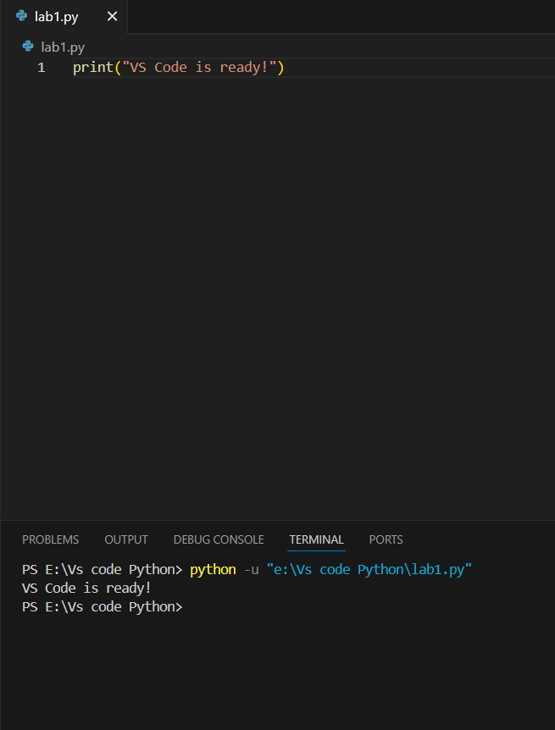
Task 5: Declaring different data types and initializing them.
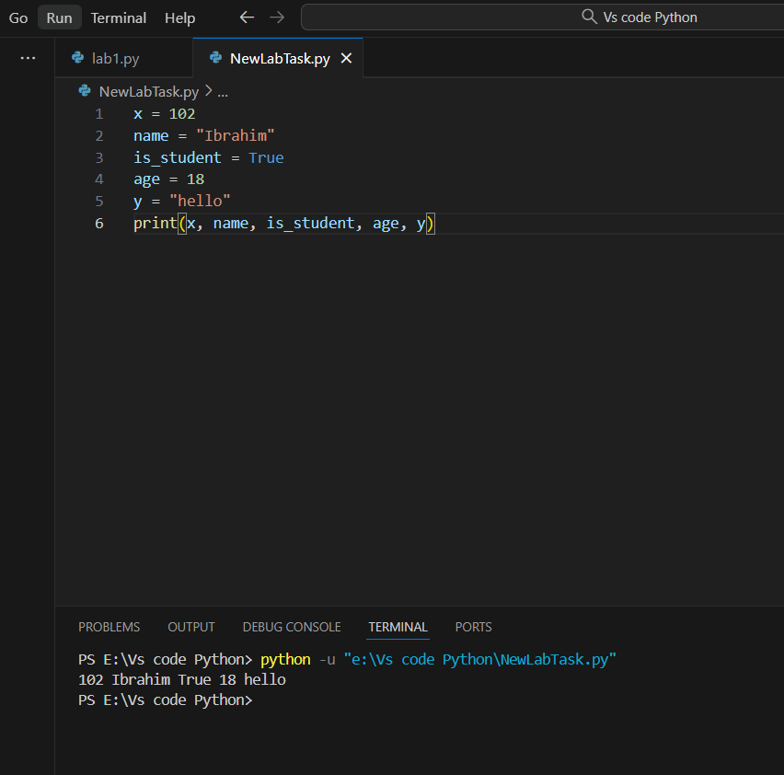
Task 6: Writing a program using conditional structures to check if the number is positive , negative , or zero.
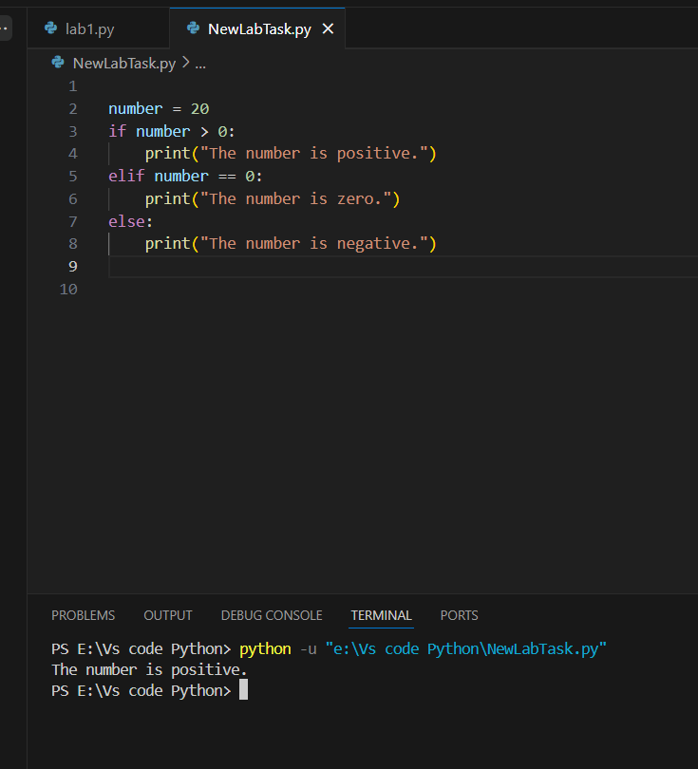
Task 7: Taking two numbers from user and returning their sum.
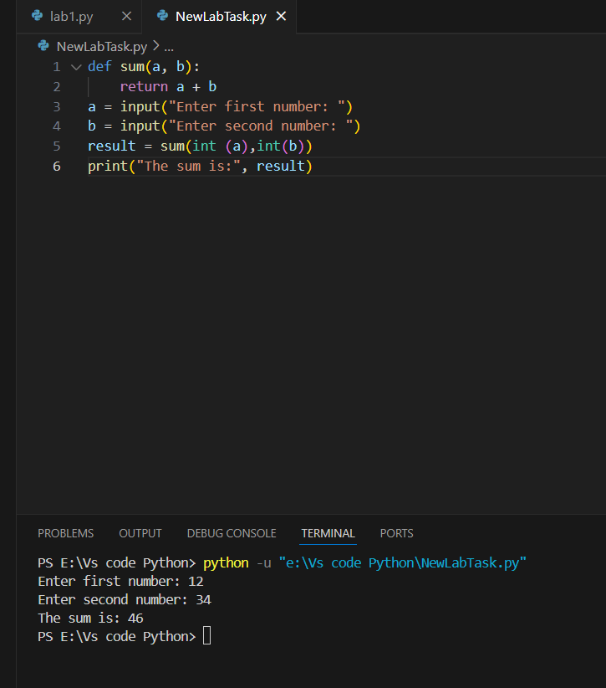
Task 8: Printing even numbers from 2 to 20 using for loop.
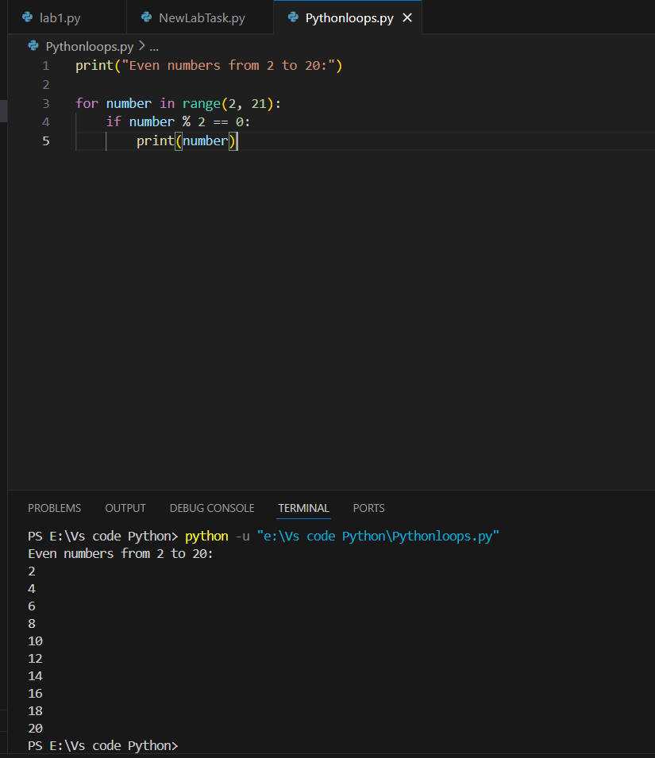
Part 2: Printing numbers from 10 to 1 using while loop.
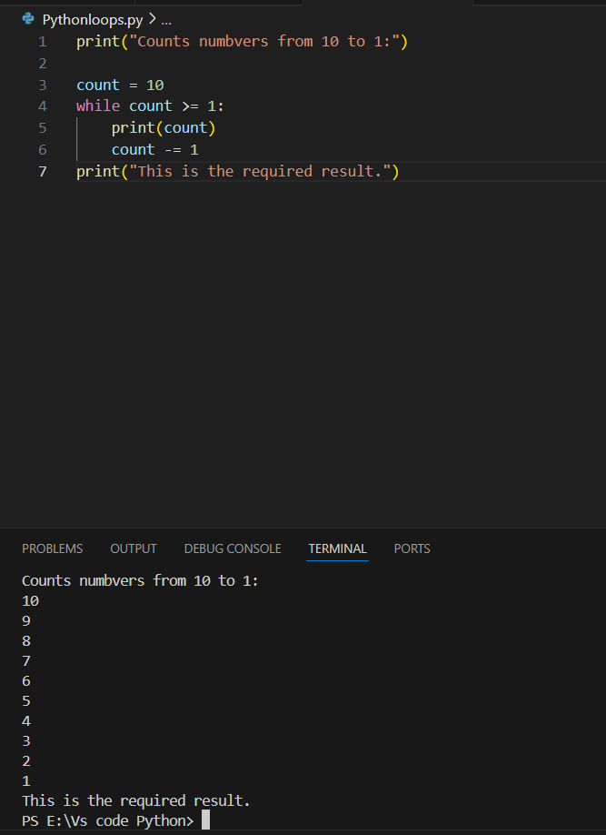
Task 9: Importing random library to display a random number from 1 to 50.
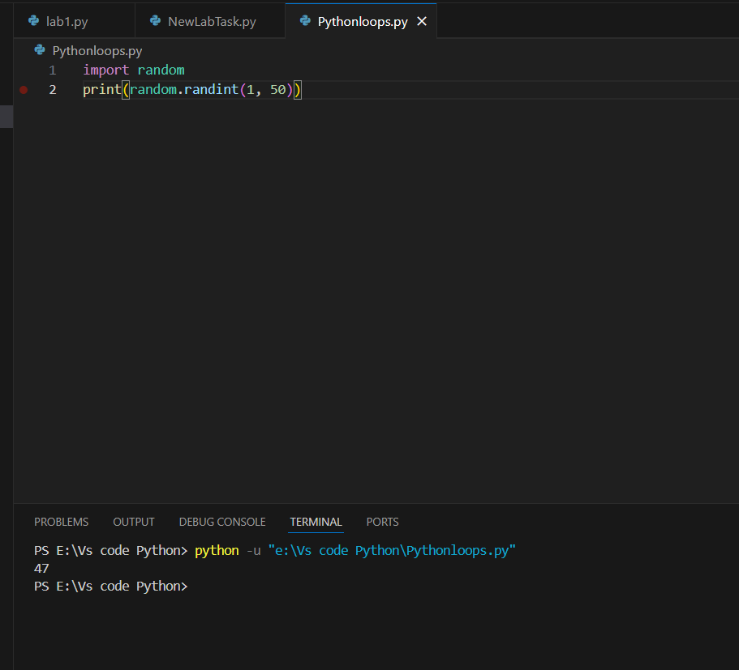

Task 10:

Different types of error:
- Semantic error: we wanting to display sum but it is displaying them by combining them instead.

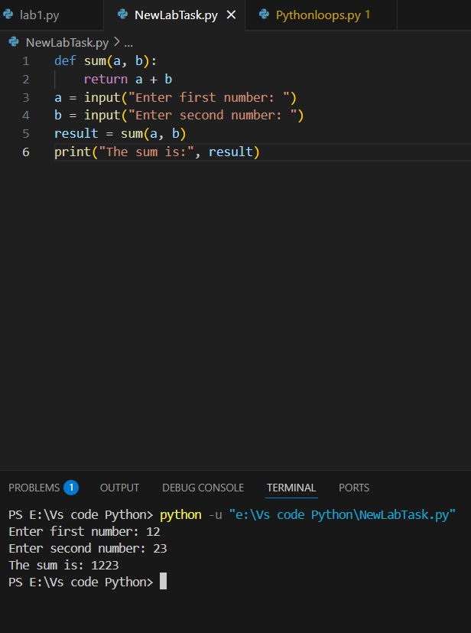
- Syntax error: Proper data type is not used.
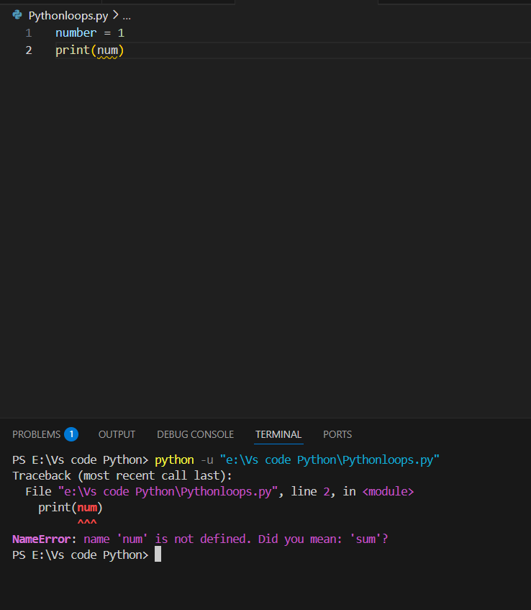
- Runtime error: The program will not run due to division by zero so it is a runtime error.
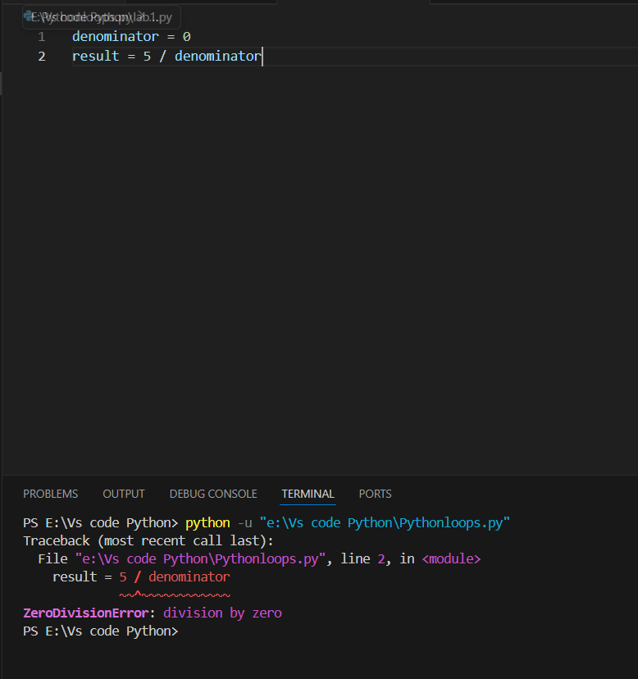

Python Vs Code Tasks:
- AI Mood Detecter: (Code)
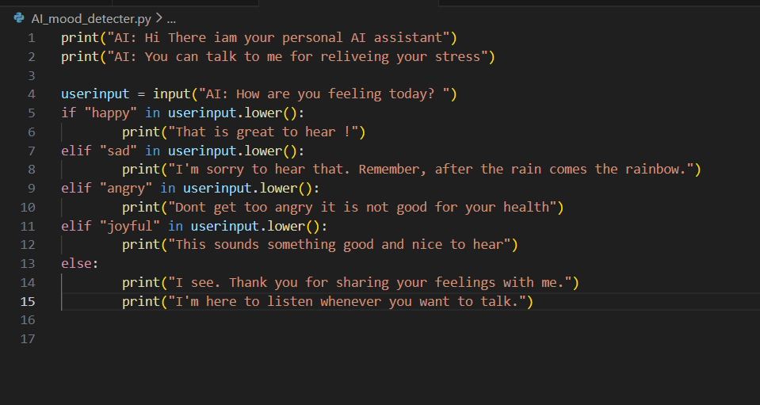

Output:
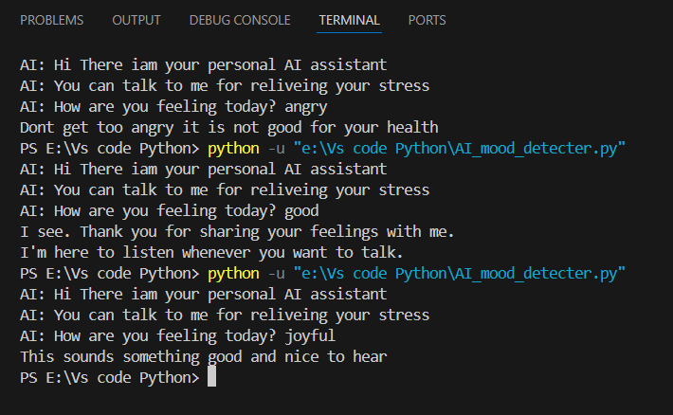

- Smart ChatBot: (Code)

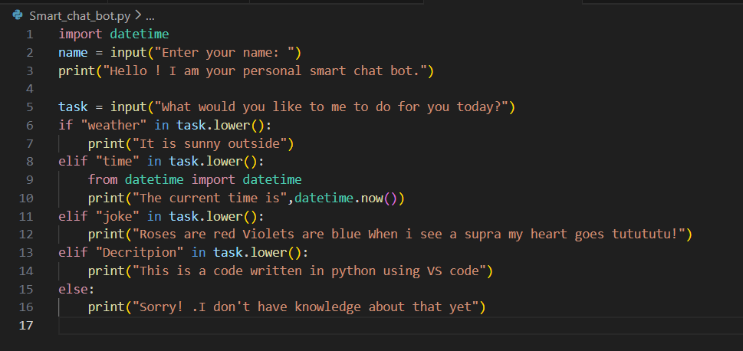

Output:

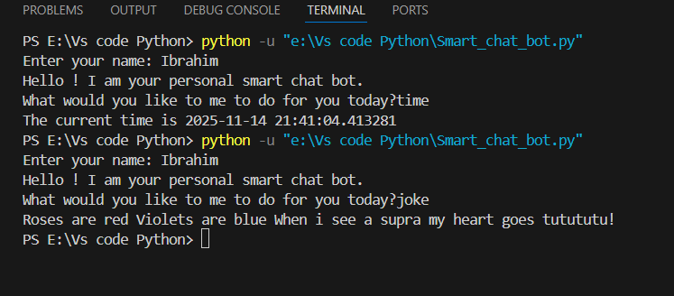

- Voice like Smart Assistant: (Code)

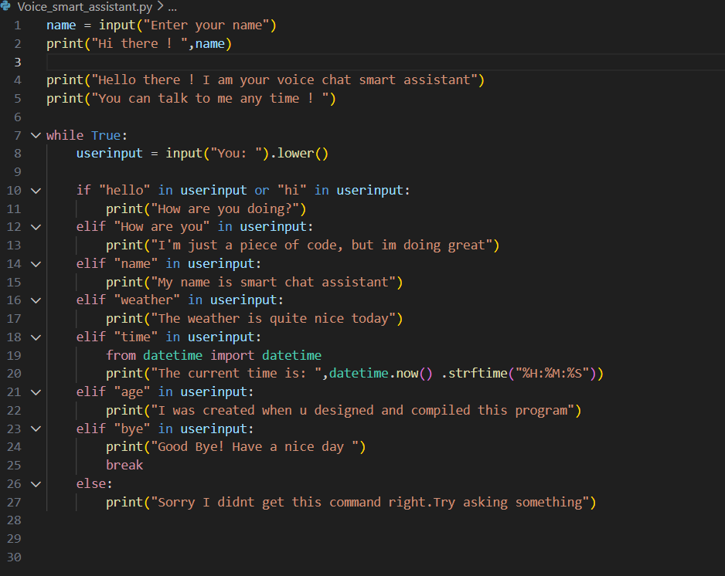

Output:
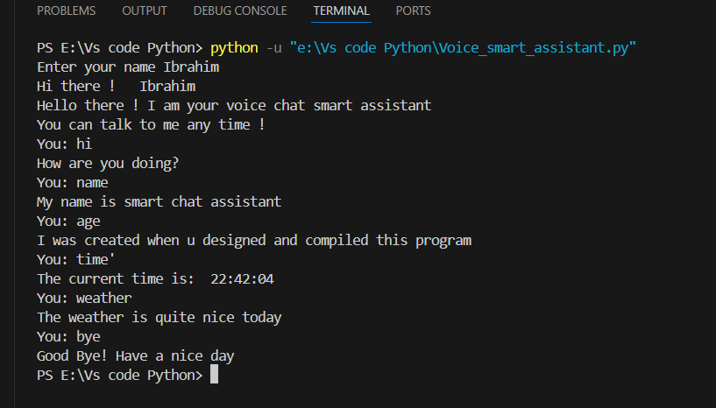

- Weather information AI: (Code)
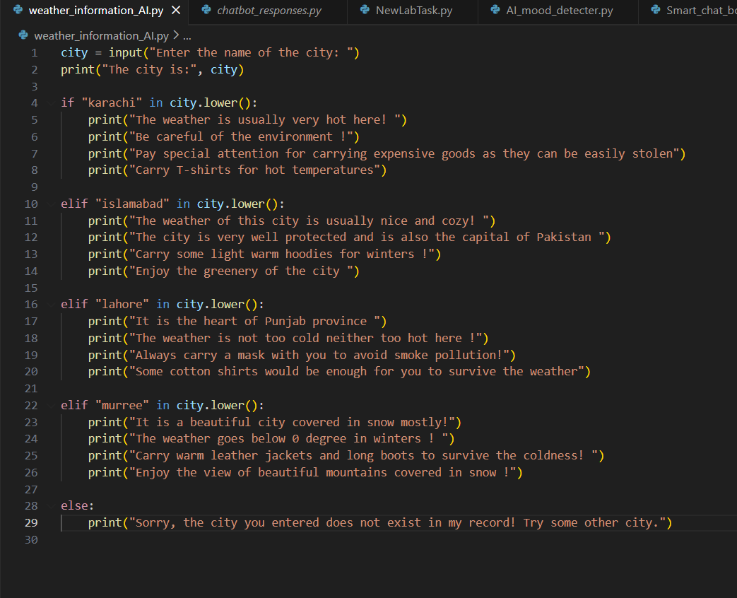
Output:
